YOUR PAPER TITLE HERE (USE TITLE CASE-FONT SIZE 16 AND BOLD)

^{1*}First Author, ²Second Author, ³Third author

¹School of Business, University of the Witwatersrand,
1 Jan Smuts Ave, Johannesburg, 2000, South Africa*
author1@email.com

²School of Business,, Cairo University,
شارع الجامعة، 12613 , Egypt
author2@email.com

³School of Business, University of Chicago,
5801 South Ellis Avenue, Chicago, Illinois 60637
author3@email.com

ABSTRACT
The abstract should include the following subheadings;

Purpose of the study:

Short introduction of problem statement:

Method/methodology:

Results of the study:

Conclusion and policy recommendation:

Keywords: about four to six key words separated by commas and in italic.

INTRODUCTION

STATEMENT OF THE PROBLEM

RESEARCH OBJECTIVES

RESEARCH HYPOTHEIS/QUESTIONS

THEORITICAL REVIEW/ FRAMEWORK

EMPIRICAL REVIEW

CONCEPTUAL FRAMEWORK

RESEARCH METHODOLOGY

RESULTS AND DISCUSSIONS

CONCLUSIONS

RECOMMENDATIONS

REFERENCES

GENERAL GUIDELINES

A. Page Size and Layout
Set your page as A4 and margins as follows:
• Left Margin 1"
• Right Margin 1"
• Top Margin – 1"
• Bottom Margin – 1"
You should use Times Roman of size 12 for all fonts in the paper and 1.5 spacing.
When you submit your paper print it in one-column format, including figures and tables. In addition, designate one author as the “corresponding author”. This is the author to whom proofs of the paper will be sent. Proofs are sent to the corresponding author only.

B. Body Paragraphs, FIGURES AND TABLES and References

B1. Body paragraphs
The main text for your paragraphs should be 12pt font. Use block format paragraphs.

B2. Figures
Place the title of the Figure below the chart. For Example:
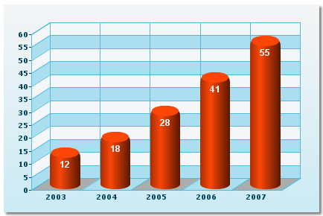
Figure 1: (Below the figure)

B3. Tables
Place table titles above the tables. For example:

Table 1: APA style
Gender | Frequency | Percentage
Male | 6 | 60
Female | 4 | 40

B4. References
APA style, MLA or Chicago (N/B: Be consistent with a style of referencing you choose)

C. NUMBER OF PAGES FOR THE ARTICLE
The standard number of pages of the article should be between 10 pages to 25 pages (font size 12 Times New Roman, 1.5 spacing).

